Department of Electrical and Computer Engineering
North South University



CSE445 Report

Prediction of Points Table of a Football League Using Machine Learning

Group: 01
Group Members:
Abdullah Al Hasan ID: 1831362042,
Jannatul Ferdous ID: 2031530642,
Adib Salahuddin ID: 2111122642,
Jonak Bhowmik ID: 2211148642

Faculty:
Riasat Khan
Assistant Professor
ECE Department
Summer, 2024

Individual Contribution Table

Section | Contributing Member Name
IEEE/LaTEX formatting | Jannatul Ferdous
Turnitin check | Jannatul Ferdous | Overall Similarity:  21%
Grammarly check | Abdullah Al Hasan | Grammarly Score:  97
Abstract | Adib Salahuddin
Keywords | Jonak Bhowmik
Introduction Motivation | Adib Salahuddin
Paper Review 1 | Jonak Bhowmik | [4]
Paper Review 2 | Jannatul Ferdous | [5]
Paper Review 3 | Abdullah Al Hasan | [6]
Paper Review 4 | Adib Salahuddin | [7]
Introduction Second-Last Paragraph (describe your work) | Adib Salahuddin
Proposed System (Dataset and Preprocessing) | Jonak Bhowmik
Proposed System (Model description) | Decision Tree | Abdullah Al Hasan
 | Random Forest
 | K-NN
 | SVM
 | AdaBoost
 | XGBoost
Results and Discussion | Abdullah Al Hasan &  Jannatul Ferdous
Figure and Table Title Formatting | Abdullah Al Hasan &  Jannatul Ferdous
Conclusions | Jannatul Ferdous
Equations formatting | Jonak Bhowmik
References Formatting in IEEE format | Adib Salahuddin &  Jonak Bhowmik

Prediction of Points Table of a Football League Using Machine Learning

Jannatul Ferdous
Electrical and Computer Engineering North South University
Dhaka, Bangladesh jannatul.ferdous27@northsouth.edu

Adib Salahuddin
Electrical and Computer Engineering North South University
Dhaka, Bangladesh adib.salahuddin@northsouth.edu

Abdullah Al Hasan
Electrical and Computer Engineering North South University
Dhaka, Bangladesh abdullah.hasan3@northsouth.edu

Jonak Bhowmik
Electrical and Computer Engineering North South University
Dhaka, Bangladesh jonak.bhowmik@northsouth.edu

Abstract—This particular project aims to predict point table of a particular season of the English Premier League using several machine learning algorithms. To predict this, we use two datasets one containing 532 rows and 18 columns, the other containing 318 rows and 12 columns. In this particular study we evaluated using machine learning models such as: K-NN, Decision Tree, Random Forest, Support Vector Machine, Ada Boost, XG Boost both with default and optimized Hyperparameter. In terms of default hyper parameter, we get the best result from XG Boost. Where, for optimized hyperparameter we get the best result from Support Vector Machine. In our next step we have applied stacking on both of the hyperparameters. In stacking for cross validation, we have used Grid Search CV and for the metal model we used Logistic Regression. In here we get accuracy result by stacking optimized hyperparameter. Since stacking classifier for optimized hyperparameter gave us the best result in Accuracy, Precision, Recall and F1 score we have applied LIME explainable AI on it to analyze specific predictions. Then we applied SMOTE for training samples to make sure that the imbalanced data have been well balanced. This entire project was successful to almost predicting the near perfect points table for the 2023-2024 English Premier League. In this study, stacking classifiers provide the best performance, with an accuracy rate of 0.63 and an F1 score of
0.70. However, other machine learning algorithms can be applied to achieve a better accuracy rate. So, as a result, there is space for future studies to have even better predictions if wanted.
Index Terms—English Premier League, Points Table, Confu- sion Matrix, Normalization, Classification, Ensemble Learning, Stacking, Decision Boundary, LIME, SMOTE.

- Introduction
Football is currently considered one of the biggest sports around the world. It is widely played and celebrated around the world. Football’s inception was in England in the late mid to late 19th Century. Today, this sport is celebrated in over 200 countries around the world. Since England is considered the birthplace of football, controlled by the Football Association of England, the English Premier League is one of the most prestigious and historically rich football competitions worldwide. [1] In the 2023-2024 season of the English Premier League, over 4.7 billion people viewed the English
Premier League. [2] Some of the prestigious football clubs in England and worldwide participate in this competition, which features some of the most skilled footballing athletes globally. While the history of football prediction is unknown, the ritual of predicting match results or tournament winners has been done since the early 1900s in England for betting purposes. [3] As technology has advanced, score prediction has become more accurate. Sports betting accurate football predictions have been more demanding than ever in this age of Fantasy League Football. It is also a topic that has been widely researched using various engineering methods.

For instance, Rodrigues et al. [4] utilized the English Premier League team and match statistics to construct a machine learning model that predicts a football match result to boost the profit margin in football betting. At the onset, the dataset consisted of 1900 matches with 31 attributes; however, after the application of the Boruta algorithm, the authors eliminated attributes that were not relevant and reduced the number to 18. The author divided the dataset into two parts: data from four seasons for training and the remaining season data for two-phase testing, where the Random Forest algorithm model, in the second phase, delivered the best hit rate and profit margin of 65.26% and 26.74%, sequentially. The authors planned to integrate the model into a decision support system to assess and provide support to the sports betting industry.

Huba´cˇek et al. [5] employed the machine learning method to determine soccer results. The authors used a variety of historical soccer datasets focusing on past match results like the 2017 Soccer Prediction Challenge dataset for this research. This research analyzed models developed across four decades and highlighted various techniques like Bayesian inference, logistic regression, and machine learning classifiers. However, the early models had fewer variables. So, the newer approaches incorporated complex datasets and

advanced algorithms where random forest emerged as the most effective method in achieving higher accuracy (40% - 55%).

Jassim Almulla and his colleagues [6] applied machine learning approaches to determine the key performance metrics of football players in the Qatar Stars League(QSL). The authors collected data from the professional football matches of the QSL between 2012 and 2019, containing a record of 2,419 players who played in 18 teams in a total of 1,121 matches with 34 different measurements. However, the ranking of the teams and almost all of the features of substitute players were not available in the dataset. As the authors were interested in position-specific analysis, they discarded the information from the study. The authors tested different machine learning classifiers like KNN, Random Forest, XGBoost, Decision Tree, and SVM, and the Logistic Regression-based model was the best-performing model, with more than 80% accuracy.

Rebouj et al. [7] in this particular journal used a machine learning regression model. To predict the rankings of the football leagues and assess feature importance with historical data, Elastic Net Algorithm was used. The dataset consists of variables of points, goal difference, total of matches played, matches won, matches drawn, matches lost, goals for, and goals against. They used a dataset that acquired league’s performance matrices from 2009/ 10 season to 2021/ 2022. By using this model, they got an R² score of 0.999 and a Spearman correlation of 0.997. Which gave them an 87% accuracy score. This study however has its limitations. As the dynamic features can be improved by real factors affecting team performances.

In this current study, two public datasets were used. One carries the player stats, and the other carries the match stats. These datasets both carry more than 500 rows and various columns. The data from the dataset is transformed via aggregation, feature selection, and feature engineering. Then, the data splits between train-tests. Machine Learning models are trained with default and optimized hyperparameters, producing the classifiers evaluated using accuracy, recall, and F1 score metrics. The best machine learning model generates the points table, showcasing predictions or rankings.

This study briefly describes the machine learning approach that can be used to predict the points table of a season of the English Premier League. Here, section II describes all the proposed systems that must be used to predict the points table, including the dataset preprocessing formula, tables, figures, and the flowcharts of the working sequence. Section III presents the results in tables or figures, showcasing the hyperparameter values and performance metrics with default and optimized hyperparameters. Comparing the systems. Finally, section IV concludes the paper and discusses the plans and further studies that will be done with this study.
- PROPOSED SYSTEM
This section outlines the dataset handling and usage of classifiers to create machine-learning models. We divide the process into three subsections and label them as II-A, II-B, and II-C. In Subsection II-A, we explain the datasets. Subsection II-B discusses the preprocessing and merging of these datasets. Finally, subsection II-C implements machine learning models on the aggregated dataset.
- DATASETS
In this project, we have used multiple datasets: the player stats dataset [8] and the matches dataset [9], both of which consist of the stats of the English Premier League 2023/24 season. The first dataset contains 570 rows and 34 columns, whereas the second one comprises 760 rows and 28 columns. We wanted a dataset we aim to use in our model training. To achieve that, we planned to transform the player stats dataset into the team stats dataset. Further, we merged the team stats dataset with the matches dataset to derive the required dataset for model training, and we named it the mid-table dataset.

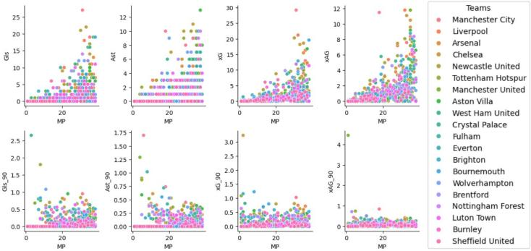

Fig. 1. The distribution of attributes with scatter plot with hue = ‘Teams’ for player-stats dataset. Here, we compared attributes like goals (Gls), assists (Ast), expected goals (xG), expected assists (xAG) etc. with the minutes played (MP) attribute.
In Figure 1, we compare attributes like goals (Gls), assists (Ast), expected goals (xG), expected assists (xAG), etc. with the minutes played (MP) attribute. We plot this to illustrate the data distribution for all the teams. It helps us inspect the player-stats dataset. For example, we can see there is a diverse distribution of data in attributes like goals,xG and xAG but xAG90 has more condensed data distribution.

- DATA PREPROCESSING
The process began using several predefined pandas func- tions and methods, from which we learned about the unavail- ability of duplicated or missing values in both datasets. We have detected some outliers in both datasets. However, we decided not to remove any rows that involve outliers, as all the rows represent necessary information about players and team fixtures. Moving forward, we used the confusion matrix to visualize the relationship between the attributes on the player stats dataset.

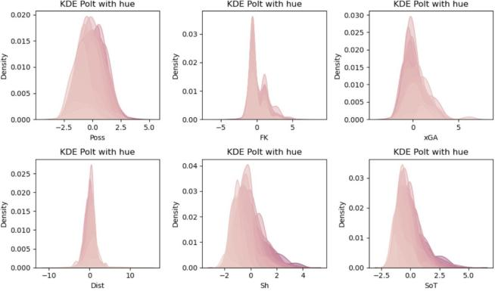

Fig. 2. The distribution of attributes with KDE plot for matches dataset where hue = ‘xG’. Here, the KDE is plotted on attributes like possession (Poss), free kick (FK), expected goal against (xGA), shot distance (Dist), shots taken (sh) and shots on target (SoT).
In Figure 2, we plotted the KDE on attributes like possession (Poss), free kick (FK), expected goal against (xGA), shot distance (Dist), shots taken (sh) and shots on target (SoT).
Here, KDE plotting helps us to observe the density of a value in an attribute. We can study the skewness in any of the attributes of the matches dataset. For example, attributes like Poss have less skewness, But FK has comparatively high skewness. Some of the attributes like xGA and SoT have skewness slightly tilted towards the left which also helps us to understand the dataset better.

Based on the initial observation, we planned to transform the player stats dataset into a new dataset consisting of the stats for all the participating teams. To achieve that, we used two aggregate functions: mean and sum. We used the sum function to aggregate attributes involving traditional footballing stats (examples: goals, assists, yellow cards). On the other hand, the mean function aggregates the attributes involving more advanced statistics (like xG, xA, and xnpG). Hence, we got the new team stats dataset, which contains 20 rows and 34 attributes.

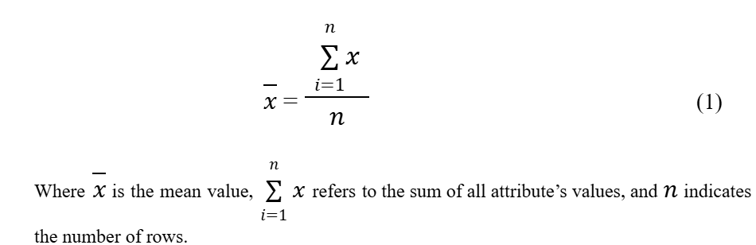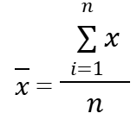
x

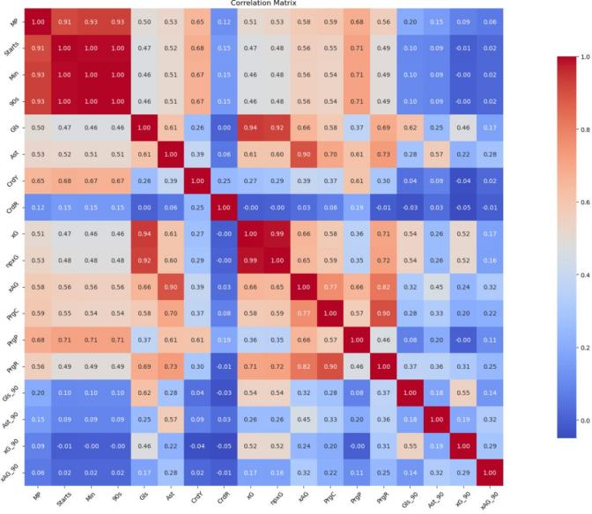
Fig. 3. The confusion matrix depicting the correlation of the attributes for the player-stats dataset.
In Figure 3, we generated a confusion matrix to inspect the relationship between the attributes and how each attribute impacts the other attributes. From this illustration, we can see that some attributes dominate other attributes which helps us in feature selection. For example, we can see that attributes like goals and assists have dominated the other features. So, we can exclude them from the next steps of preprocessing.

datatype. We also created 16 new empty columns with the same names and datatype in the matches dataset.

Following the process, we merged the datasets: the team stats dataset and the matches dataset. However, after analyzing the datasets, we identified a problem. We have found inconsistencies in naming the teams. So, we have to normalize the team name for both datasets. We had to remove all the capital letters and the space between the team names and replace the inconsistent names with the normalized names. We also normalized the venue attribute values, an attribute of the matches dataset. After that, we mapped the corresponding column names of both datasets. We used the
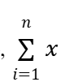

The team stats dataset has 34 attributes. Among the 34 attributes, we focus more on the team name and advanced statistics. We use feature engineering to create a new attribute out of the existing statistics-based attributes, where we aim to split the values of those stats into home and away stats. We deliberately split the values into a 60-40 ratio to give more importance to the home side. So, we created 16 new attributes out of 8 existing attributes, which are the home and away stats of the teams, and maintained the same float
team stats dataset and the opposition team empty columns of the matches dataset with the corresponding away stats. The approach will be the same when the venue value is away; we just filled the empty away statistics columns with the corresponding values of the team stats dataset and the opposition team empty columns with the corresponding home stats. After that, we merged the datasets to get the desired dataset named the mid-table dataset, which has 44 attributes in total.

After checking the newly created mid-table dataset, we

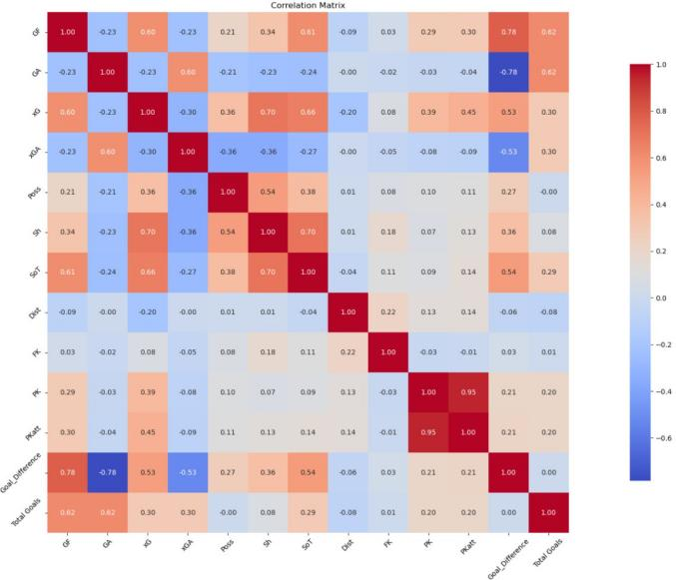

Fig. 4. The confusion matrix depicting the correlation of the attributes for the matches dataset.
In Figure 4, we generated a confusion matrix to inspect the relationship between the attributes and how each attribute impacts the other attributes. From this illustration, we can see that some attributes dominate other attributes which helps us in feature selection. For example, we can see that attributes like GF and GA have a negative relation with the other features. So, we can exclude them from the next steps of preprocessing.

found that some attributes strongly influenced other attributes, and some didn’t contribute that much. These attributes could give us an overfitted machine-learning model. So, to avoid the threat, we decided to introduce a new attribute, which combines the goals-related features in a match. Then, we removed some unnecessary attributes. After removing unwanted columns from the mid-table dataset, we settled on 760 rows and 32 attributes for the model training. In addition, we repositioned the column so that it became the last attribute of the Mid-Table dataset.

Feature encoding is a machine-learning technique that converts non-numeric values to numerical values. In the results column, we use this technique to convert the W, D, and L into 3, 1, and 0, respectively. Later, we explicitly choose the attributes with numerical values to train the model.

Standardization, or Z-score normalization, is a technique to rescale the data distribution. It brings the value of the attribute within 0 and 1. So, to rescale the attribute values and reduce the chances of overfitting, we introduce Z-score normalization to the mid-table dataset.
standard deviation of that attribute.
To create a machine learning model, we perform dataset splitting. Here, we planned to use the hold-out or train-test approach, which means we split the mid-table dataset into two parts: the training and the test part. We split the dataset so that among 760 rows, we allocated 240 rows for testing purposes, where each team contributed 12 rows. We allocated 520 rows to the training part, where teams contributed 26 matches each. Here, each team contributed equally in both the training and testing parts. Hence, we have allocated 68.42% for the training part and 31.58% for testing purposes.
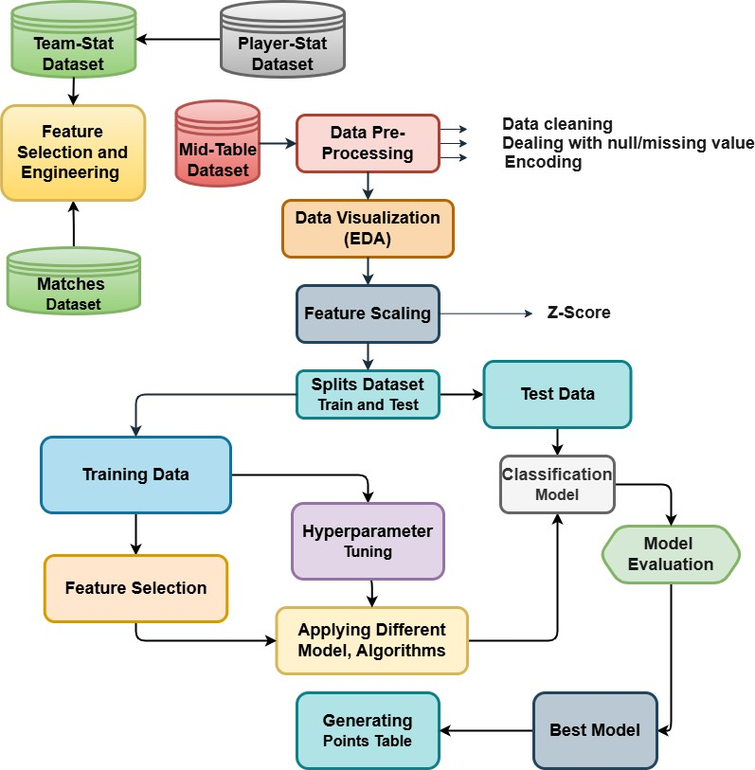
Fig. 5. The flow chart of the proposed football league points table prediction system.
Figure 5 illustrates the process of transforming player and match datasets into a merged ”mid-table dataset” through feature selection, engineering, and aggregation. It traces splitting the dataset for training and testing, optimizing hyperparameters, and evaluating multiple classifiers to identify the best-performing model. The final step involves generating the points table based on the best model’s performance metrics.

- Machine Learning Models
  - Decision Tree: A Decision Tree is a supervised machine-learning technique used for classification and Re-

Xnormalized
x − x¯
=
σ
gression problems. However, it is mostly used for solving classification problems. This classifier is tree-structured, with

When X_{normalized} is the normalized value, x is an individual data point, x¯ is the mean of a single attribute and σ is the
internal nodes positioned for a dataset’s features, branches for the decision rules, and each leaf node for the result.

  - Random Forest: Random Forest is a machine learn- ing technique in supervised learning that uses the ensemble learning technique. In addition, it is applied to regression and classification problems. It is based on the principle of ensemble learning, which is the process of combining different classifiers to solve a complex problem while improving the model’s performance.
  - KNN: One of the most simple machine learning algo- rithms based on the supervised learning technique is K-Nearest Neighbor(KNN). The algorithm places the new data into the category most similar to the existing categories based on the assumption that the latest and available data are identical. Therefore, the KNN algorithm makes it simple to classify newly acquired data into an appropriate category.
  - SVM: Support Vector Machine(SVM) is among the most popular supervised learning algorithms. It is used for classification and regression problems, primarily for classifi- cation problems. In order to make it simple to classify new data points, the SVM algorithm creates the best line, which is called the ”Decision Boundary,” that can divide multidimensional space into classes.
  - AdaBoost: The term ”AdaBoost” is an acronym that stands for ”Adaptive Boosting.” It is a robust ensemble learning algorithm that can potentially improve the overall performance of vulnerable and inexperienced individuals and develop a robust classifier. However, it is sensitive when dealing with data containing outliers and noise.
  - XGBoost: The ensemble learning technique known as ”XGBoost,” which stands for ”Extreme Gradient Boosting,” combines the predictions from multiple weak models to get a stronger prediction. It is a distributed gradient boosting library developed for efficient and reliable machine learning model training. Because of its capacity to manage big datasets, it has emerged as one of the most popular and widely used machine learning algorithms.
- PROPOSED SYSTEM
This project evaluated several machine learning models for predicting the points table. These included Decision Tree, Random Forest, K-Nearest Neighbor(KNN), Support Vector Machine(SVM), Adaptive Boosting(AdaBoost), Extreme Gra- dient Boosting(XGBoost). The top performer was SVM, which had an accuracy of 61 with default hyperparameters. Hyperpa- rameter optimization had a significant impact on the models. All of the models showed better accuracy with optimized hyperparameters. In this case also, the top performer was SVM, with an accuracy of 62. Then, we applied stacking on the best model and got the best of all the results with an accuracy of 63.75 with optimized hyperparameters. In conclusion, the most effective model for this project would be stacking.
TABLE I
HYPERPARAMETER VALUES’ RANGES FOR VARIOUS ML MODEL

Model | Hyperparameter Value Range | Optimized value

Decision Tree | criterion:  [gini, entropy], max depth: [None, 10, 20, 30] | criterion: ’entropy’, min samples leaf: 1, min samples split: 0.1,  splitter: ’best’
Random Forest | n estimators:  [100, 200, 300]  max depth: [None, 10, 20,  30]  criterion: [gini, entropy] | criterion: ’gini’, max depth: 10,  min samples split: 5, n estimators: 100
KNN | algorithm: [’auto’, ’ball tree’, ’kd tree’, ’brute’]  leaf size: [10, 30, 50, 100]  n neighbors: [3, 5, 10, 15,  20]  p: [1, 2, 3] | algorithm: ’ball tree’, leaf size: 5,  n neighbors: 33,  p: 2
SVM | C: [0.1, 1, 10, 100],  gamma: [1, 0.1, 0.01,  0.001], kernel: [’rbf’,  ’poly’, ’sigmoid’] | C: 0.1, class weight: None, gamma: ’scale’, kernel: ’linear’
AdaBoost | learning rate: [0.01, 0.1, 1],  n estimators: [50, 100, 200] base estimator max depth: [1, 2, 3] | algorithm: ’SAMME’, learning rate: 0.5,  n estimators: 200
XGBoost | learning rate: [0.01,  0.05, 0.1, 0.2, 0.3],  max depth: [3, 5, 7, 10,  15], n estimators: [100,  200, 300, 500, 1000] ,  subsample: [0.6, 0.7, 0.8,  0.9, 1.0] | learning rate: 0.1,  max depth: 5,  n estimators: 100,  subsample: 0.8
Table I illustrates the hyperparameter values’ ranges and the corresponding optimized hyperparameters for all the ML models.

TABLE II
PERFORMANCE METRICS OF VARIOUS ML MODELS WITH DEFAULT HYPERPARAMETERS

Model | Accuracy MAE | Precision/ MSE | Recall/ RMSE | F1-score/ R2  coefficient

- CONCLUSION
Decision Tree | 0.53 | 0.56 | 0.63 | 0.59
Random Forest | 0.58 | 0.59 | 0.71 | 0.65
KNN | 0.55 | 0.65 | 0.59 | 0.62
SVM | 0.61 | 0.64 | 0.72 | 0.68
AdaBoost | 0.57 | 0.59 | 0.67 | 0.63
XGBoost | 0.60 | 0.64 | 0.72 | 0.68
Stacking | 0.61 | 0.65 | 0.76 | 0.70

Sports betting is a topic that has been widely researched using several novel engineering methods. While other sports are important, football has gained its reputation as a sport
Table II Performance metrics of various ML models with default hyperparameters have been illustrated in Table II.

TABLE III
PERFORMANCE METRICS OF VARIOUS ML MODELS WITH OPTIMIZED HYPERPARAMETERS

Model | Accuracy MAE | Precision/ MSE | Recall/ RMSE | F1-score/ R2  coefficient

Decision Tree | 0.55 | 0.65 | 0.64 | 0.65
Random Forest | 0.59 | 0.60 | 0.69 | 0.64
KNN | 0.60 | 0.63 | 0.68 | 0.66
SVM | 0.62 | 0.65 | 0.75 | 0.70
AdaBoost | 0.57 | 0.58 | 0.70 | 0.63
XGBoost | 0.61 | 0.63 | 0.69 | 0.66
Stacking | 0.63 | 0.65 | 0.76 | 0.70
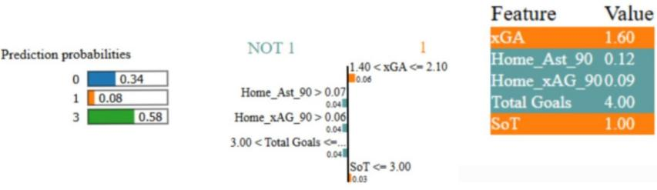
Table III Performance metrics of various ML models with optimized hyperparameters have been illustrated in Table III.

Fig. 6. Machine learning model prediction interpretation by LIME explainable AI library.
Figure 6 shows the LIME explainable AI library’s interpretation of the model’s decision-making, predicting Class 0 with a probability of 0.34, Class 1 with a probability of 0.08 and Class 3 with a probability of 0.58. Key contributing features include xGA (1.60), HomeAst90 (0.12), HomexAG90 (0.09), Total Goals (4.00), and SoT (1.00). Threshold insights reveal contributions from 1.40 ¡ xGA ¡= 2.10 (0.06), HomeAsˆ90 ¿ 0.07 (0.07),
HomexAG90 ¿ 0.06 (0.06), 3.00 ¡ Total Goals (0.04), and
SoT ¡= 3.00 (0.03), highlighting how these features influenced the prediction.

TABLE IV
COMPARISON OF THE PROPOSED SYSTEM WITH EXISTING WORKS
Ref | Model | Accuracy | F1-score

[4] | Random Forest | 0.65 | N/A
[7] | Regression Model | 0.75 | N/A
Ours | Stacking | 0.63 | 0.70

Table IV llustrates comparison of the proposed Prediction of Points Table system with other existing works on Prediction of Points Table of a Football League Using Machine Learning .

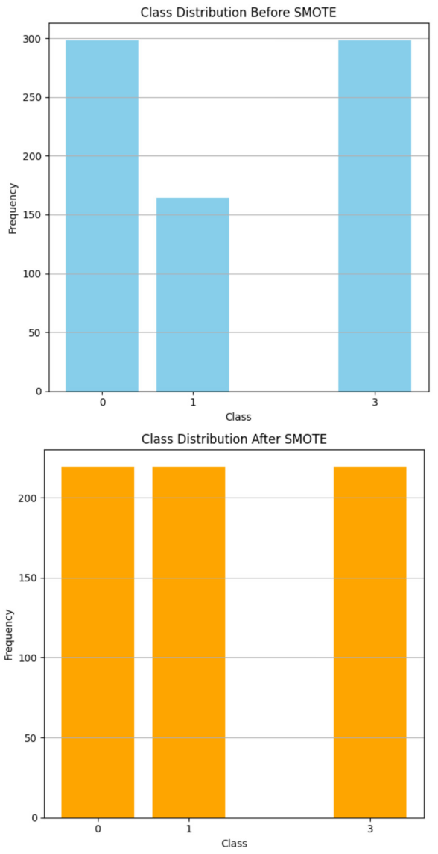

Fig. 7. SMOTE application for training samples.
Figure 7 illustrates the impact of using the SMOTE technique on the machine learning model’s predictions. Before applying SMOTE, the dataset was imbalanced, with Class 0 and Class 3 having 298 samples each, while Class 1 had only 164 samples. After applying SMOTE, the dataset was balanced, with each class having 219 samples, ensuring equal representation and reducing class imbalance for better model performance.

that can bring people together from anywhere in the world. As time progresses, technological advancements have allowed for more accurate score prediction.
Previous studies have shown how real factors affect team performance and which dynamic factors can be targeted to improve specific performance areas. In this study, we explored a machine learning approach to predict the points table of a season of the English Premier League. We used raw match and player data to train various machine learning models to see which works best in the previous Our approach of stacking classifiers provides the best performance, with a satisfactory accuracy rate and F1 score. We acknowledge

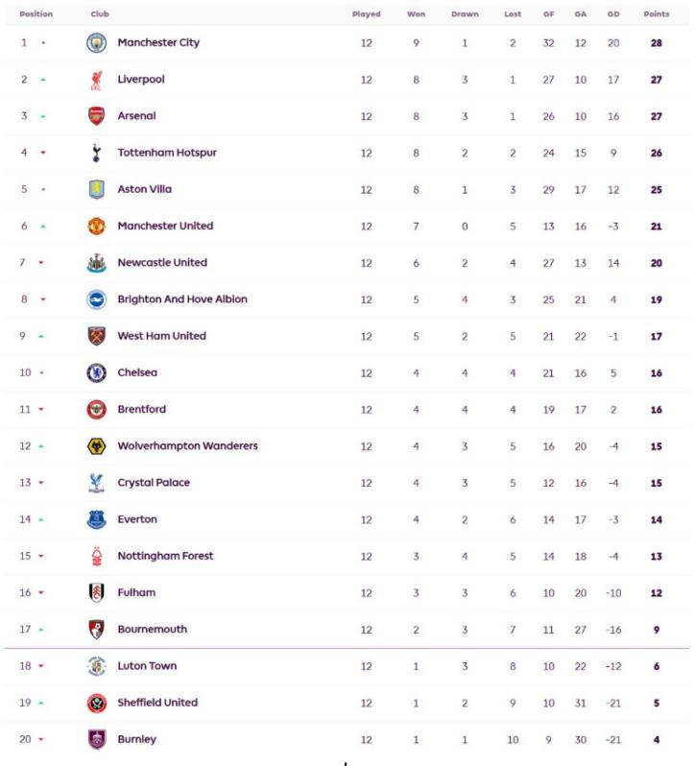
a limitation that our accuracy rates can be improved using other machine learning algorithms. Hence, our future work will effectively focus on trying out these machine-learning processes for multiple seasons and better predicting the scores of matches. Hence, our future work will effectively focus on trying out these process of machine learning for multiple seasons and get to do better prediction of the scores of matches.

References
- S. Giulianotti and R. Robertson, ”The Globalization of Football or the Footballization of theWorld,” Academia.edu. [Online]. Avail- able:https://www.academia.edu/6820744/The Globalization of Football or the Footballization of the World.

- ”Premier League TV Viewership Statistics,” Sport- ingPedia, Jul. 3, 2023. [Online]. Available: https://www.sportingpedia.com/2023/07/03/premier-league-tv- viewership-statistics/.
- ”The Revolution of Soccer Predictions: Transitioning from Fun to Business,” Sports Fanfare, Sep. 29, 2023. [Online]. Available: https://sportsfanfare.com/2023/09/29/the-revolution-of-soccer- predictions-transitioning-from-fun-to-business/.
- F Rodrigues and Aˆ Pinto, “Prediction of football match results with

Fig. 8. The points table of the English Player League, 2023/24 season. Here, the point table ranked the teams based on the points in the first 12 matches of that season.

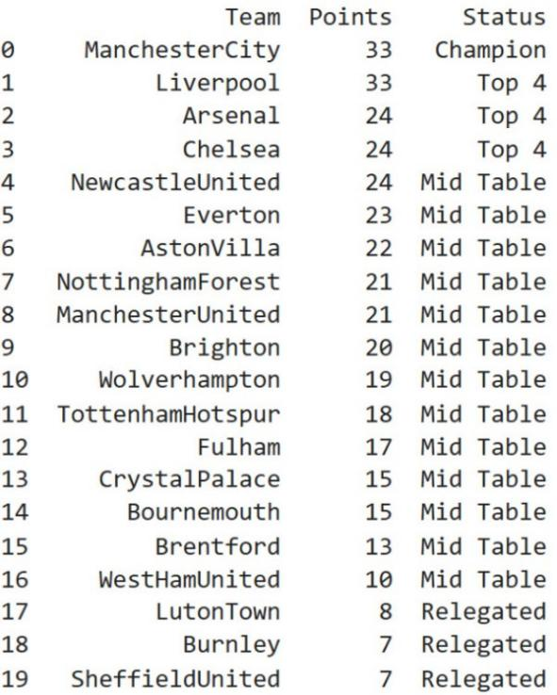

Fig. 9. The generated points table using the mid-table dataset. This table also shows the ranking of teams based on points collected in 12 matches. We have used the stacking technique to get this points table.
Machine Learning,” International Conference on Industry Sciences and Computer Science Innovation (iSCSi), 2022, pp. 463–470.
- O. Huba´cˇek, G. Sˇourek, and F. Zˇ elezny´, ”Forty Years of Score-Based Soccer Match Outcome Prediction: An Experimental Review,” *IMA Journal of Management Mathematics*, vol. 33, no. 1, pp. 1–18, Jan. 2022
- J. Almulla and T. Alam, ”Machine Learning Models Reveal Key Performance Metrics of Football Players to Win Matches in Qatar Stars League,” in IEEE Access, vol. 8, pp. 213695-213705, 2020
- M. Rebbouj and S. Lotfi, ”Football League Ranking Prediction Using Machine Learning Regression Model,” Annals of Applied Sport Science.
- Orkun Aktas¸, June 2024, “Premier League All Players Stats 23/24,” Kaggle.com. [On- line].Available:https://www.google.com/url?q=https://www.kaggle.com
/datasets/orkunaktas/premier-league-all-players-stats- 2324/data&sa=D&source=docs &ust=1734885528587497&usg=AOvVaw33gHFgcJJf99ICocn7KRzM
- Mert Bayraktar, Nov. 2024, “English Pre- mier League Matches 2023/2024 Season,” Kag- gle.com.[Online].Available:https://www.kaggle.com/datasets/ mertbayraktar/english-premier-league-matches-20232024-season

